Development and Validation of a Two-Input Transfer Function Analysis for Blood Pressure, CO₂, and Cerebral Blood Flow Dynamics
Abstract deferred until the final results and interpretation are settled.

Introduction
The brain requires continuous blood flow while arterial pressure changes from moment to moment. Cerebral autoregulation helps limit the effect of these changes on cerebral perfusion. Dynamic cerebral autoregulation focuses on how that response develops over time and is commonly assessed using mean arterial pressure (MAP) and cerebral blood flow velocity (CBFV), measured with transcranial Doppler. CBFV is used as a surrogate for changes in flow when the diameter of the insonated artery is sufficiently stable.
Transfer function analysis (TFA) describes how fluctuations in one signal are related to fluctuations in another across frequency. A fluctuation at 0.10 Hz repeats about every 10 seconds, whereas one at 0.20 Hz repeats about every 5 seconds. At each frequency, gain describes the size of the CBFV response relative to the input, and phase describes their relative timing. A one-second timing difference is one-tenth of a cycle, or 36 degrees, at 0.10 Hz. Coherence describes how consistently the two signals maintain a linear relationship at that frequency.
Most pressure–flow analyses use a single-input, single-output (SISO) model with MAP as the input and CBFV as the output. This pairwise description is useful, but MAP is not the only input that can influence CBFV. Carbon dioxide changes cerebrovascular tone, and end-tidal CO₂ provides a practical breath-to-breath measure of carbon dioxide during resting recordings. If MAP and CO₂ fluctuate together, a MAP-only model can attribute part of the CO₂-related CBFV response to MAP. A CO₂-only model has the corresponding problem in the opposite direction.
The relevant relationship is MAP–CO₂ input coherence. It describes how much frequency-specific information the inputs share; it is different from MAP–CBFV or CO₂–CBFV coherence. Two signals may both contain fluctuations at the same frequency but have low coherence if their relative timing or amplitude changes across recording segments. Coherence is high only when their relationship remains consistent. Two separate SISO analyses therefore retain useful pairwise descriptions but do not estimate each input while accounting for the other.
A multiple-input, single-output (MISO) model estimates the MAP and CO₂ responses together. The response associated with one input is conditional on the other input being included. In this paper, a pathway means the frequency-specific response component assigned by the model to one measured input. It is not an independently measured anatomical or causal pathway in a human recording.
$Y = HₘM + H꜀C + E$ | (1)
The equation represents CBFV variation as the MAP contribution, the CO₂ contribution, and a remaining component that the measured inputs do not explain. Separating the two responses requires some frequency-specific input variation that is not shared. Complete independence is not required, but nearly identical inputs make their individual contributions difficult to distinguish.
Previous studies provide a physiological basis for including more than one input. Panerai and colleagues found that adding end-tidal CO₂ reduced the mean-squared reconstruction error of resting CBFV. Peng and colleagues found that including additional gas-related inputs increased multiple coherence at low frequencies. These findings show that additional inputs can explain CBFV variation, but they do not establish whether each individual transfer function was recovered accurately.
MISO can therefore help in two different ways. When MAP and CO₂ are related, it can reduce systematic mixing of their responses. Even when they are independent, CO₂ can explain CBFV variation that remains in a MAP-only residual. In a finite recording, accounting for that variation can reduce the variability of the MAP estimate. These benefits must be balanced against estimating two responses from limited, noisy, or poorly aligned data.
Human recordings cannot reveal the true individual transfer functions. A model may reproduce total CBFV well while assigning part of the response to the wrong input. We therefore use a known-truth simulation: the generating responses are specified first, signals are created from them, and SISO and MISO estimates are compared directly with those known responses. A separate held-out analysis of normal-control recordings evaluates CBFV prediction when human pathway truth is unavailable.
The primary objective is to determine when MISO more accurately recovers the MAP-to-CBFV and CO₂-to-CBFV transfer functions than the corresponding SISO analyses. We examine input dependence, relative CO₂ response strength, recording duration, output noise, input measurement noise, and timing. The main displays vary one quantity at a time around a declared reference condition, with frequency on the horizontal axis and MISO advantage represented by color.

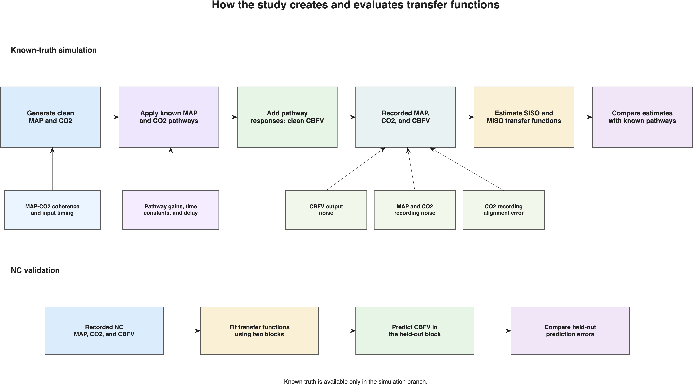
Figure 1. Study design. The known-truth branch generates CBFV from specified MAP and CO₂ responses and compares both estimators with those responses. The NC branch evaluates held-out CBFV prediction with subject-bootstrap uncertainty. Both branches use the same spectral estimators but answer different accuracy questions.

Methods

Study design and two accuracy questions
The study contains a known-truth simulation and a held-out analysis of normal-control (NC) recordings. The simulation asks whether SISO or MISO more accurately recovers a transfer function that is known because it generated the data. The NC analysis asks whether transfer functions estimated from one part of a recording predict CBFV in a different part. Human pathway truth is unavailable, so the NC analysis does not determine which estimate is physiologically correct.
For each simulated replicate and frequency, the estimated complex transfer function was compared with the complex transfer function used to generate the recording. This comparison includes both response size and timing. When a generating pathway had zero gain, absolute rather than relative error was used because a relative denominator would not be meaningful.
$E = ⟨|Ĥ−H|²⟩ / ⟨|H|²⟩$ | (2)
The primary score is the base-10 logarithm of mean SISO error divided by mean MISO error. Positive values indicate lower mean error for MISO, negative values indicate lower mean error for SISO, and zero indicates equal error. An advantage of 1 means that the mean SISO error is ten times the mean MISO error.
$A = log₁₀(E_SISO / E_MISO)$ | (3)

Frequency, power, and signal-to-noise ratio
Power describes the average squared size of a signal's fluctuations around its mean. The power spectrum distributes that variation across frequency, so a larger value near a frequency means that more of the signal's fluctuation occurs on that time scale.
$Pₓ = ⟨(x−x̄)²⟩$ | (4)
Signals were sampled at 4 Hz, which permits frequencies up to the 2 Hz Nyquist frequency. We report only 0.02–0.35 Hz because that was the prespecified physiological range of interest. Spectra were estimated with 100-second, 400-sample Hann windows, 50% overlap, linear detrending, and three-bin smoothing. The resulting simulation-bin spacing was 0.01 Hz. SISO and MISO used identical settings.

Known-truth signal generation
The simulator first creates clean MAP and CO₂ recordings. It then passes each input through a known response rule to obtain its CBFV contribution. The two contributions are added to form clean CBFV. The known response rules are the truth for the simulation; the estimators later receive only the resulting observations.
A response rule is represented in two equivalent ways. In the time domain, a kernel is a list of weights that determines how an input value affects the current and later CBFV values. A constant multiplier would create an instantaneous response with the same gain at every frequency. A kernel allows the response to develop over time and therefore allows its gain and phase to differ across frequency.
The MAP response is high-pass-like. It combines an immediate component with a slowly developing component that reduces the response to sustained MAP changes. Its time constant is 3 seconds, its high-frequency gain is 1.5, and one-quarter of that gain is retained for slow changes. The CO₂ response is a delayed low-pass response. It is built from exponentially decreasing weights with a 5-second time constant and a 3-second delay, representing a response that begins after a delay and develops gradually.
These response shapes and time constants are prescribed simulation assumptions, not transfer functions learned from NC data. NC data inform the input-spectrum shape and selected operating levels. The simulator converts each time-domain kernel to its frequency response and saves that response before observation noise or alignment error is applied.
$Y = HₘM + H꜀C + E$ | (5)

NC-derived input-spectrum shape
We used the NC recordings to choose how much input variation to place at each frequency. For each subject, MAP and CO₂ power spectra were calculated from 90-second windows. The subject-level median curves were averaged in decibels and fit with a smooth decreasing function. Only this relative shape was used; measured amplitudes and clinical units were not copied into the simulation.
$S(f) = 1 / [1 + (f/f₀)^α]$ | (6)
The fitted roll-off frequency was 0.0290 Hz and the exponent was 2.5514, with an RMS fitting error of 0.91 dB. MAP and CO₂ were assigned the same shape in the primary simulation so that input coherence could be changed without simultaneously changing their frequency distributions.

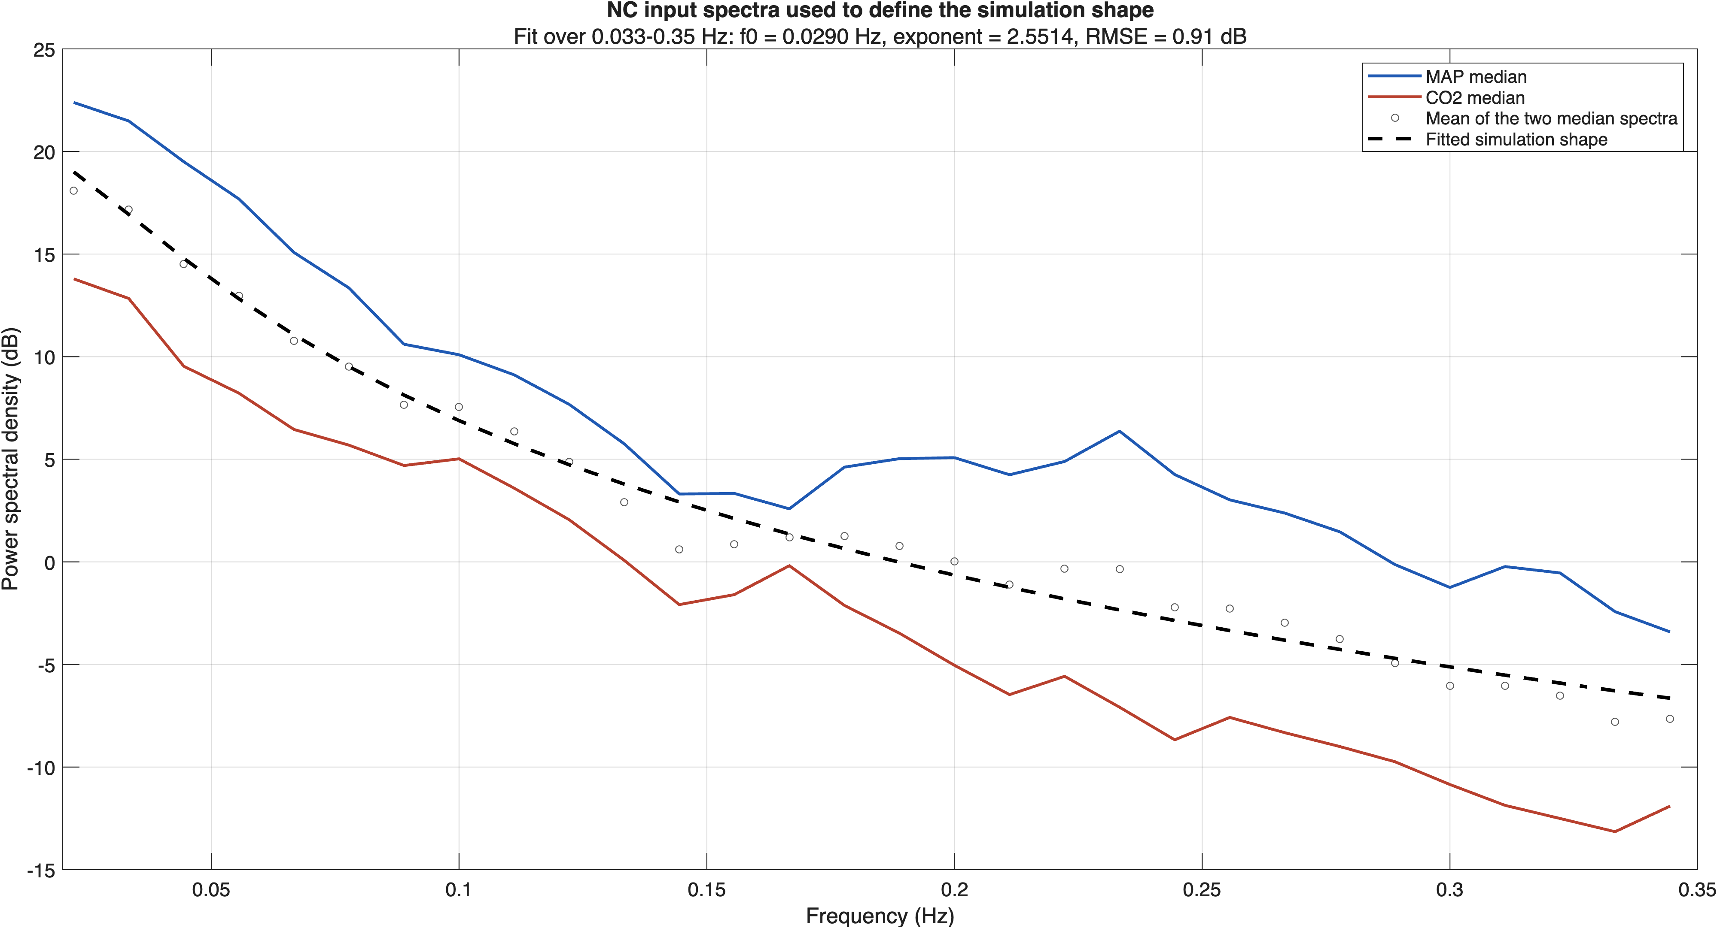
Figure 2. Origin of the simulated input-spectrum shape. Subject-median NC MAP and CO₂ spectra are shown with their fitted monotonic reference shape. The shape controls relative variation across frequency and is not presented as a universal physiological range.

Tested quantities and fixed reference condition
The main heatmaps vary one quantity at a time. Except for the named quantity, primary maps use 300 seconds of data, 10 dB signal-shaped CBFV output noise, MAP–CO₂ input coherence of 0.50, and an assigned CO₂-to-MAP pathway gain ratio of 1. These are declared reference settings, not a claim that they represent universal normal values.
The coherence levels include 0 as an independent-input control, 0.15 as an NC-informed operating level, and 0.50 and 0.95 as stronger dependence tests. The pathway-strength levels are 0, 0.25, and 1. They change the assigned CO₂ response relative to MAP, not the proportion of observed CBFV that must be attributed to CO₂.
The input-lag analysis changes when the shared CO₂ fluctuation occurs relative to MAP before CBFV is generated. It does not independently set MAP–CBFV or CO₂–CBFV phase. The alignment analysis is different: it shifts the recorded CO₂ channel after CBFV has already been generated, representing an acquisition or processing error.
MAP and CO₂ input noise were varied separately, with the other input kept noise-free. CBFV output noise was added to clean CBFV. A white noise check tested whether the primary signal-shaped noise assumption changed the conclusions.

Table 1. Simulation quantities, tested levels, fixed settings, and basis for selecting each level.
Varied quantity | Tested levels | Other settings held fixed | Basis for levels
MAP–CO₂ coherence | 0, 0.15, 0.50, 0.95 | 300 s; 10 dB CBFV SNR; pathway ratio 1 | 0 is an independent-input control; 0.15 is NC-informed; 0.50 and 0.95 are dependence tests
Relative CO₂ pathway strength | 0, 0.25, 1 | 300 s; 10 dB CBFV SNR; coherence 0.50 | Absent, weaker, and equal-gain conditions
Recording duration | 300, 600 s | 10 dB CBFV SNR; coherence 0.50; pathway ratio 1 | Shorter and longer data records
CBFV output SNR | No noise, 10, 0 dB | 300 s; coherence 0.50; pathway ratio 1 | Ideal, moderate, and severe unexplained output variation
MAP–CO₂ input lag | −6, 0, 4 s | 300 s; 10 dB CBFV SNR; pathway ratio 1 | NC-informed timing sensitivity levels
MAP input SNR | No noise, 10, 0 dB | CO₂ clean; 300 s; 10 dB CBFV SNR; coherence 0.50; ratio 1 | MAP recording-quality levels
CO₂ input SNR | No noise, 10, 0 dB | MAP clean; same reference settings | CO₂ recording-quality levels
CO₂ alignment error | −3, 0, 3 s | Both inputs clean; same reference settings | Acquisition and processing robustness check

SISO and MISO estimation
At each frequency, the spectral quantities for MAP and CO₂ play the same role that variances and covariances play in a time-domain regression. The diagonal terms describe input power, the off-diagonal terms describe shared input variation, and the cross terms describe how each input varies with CBFV.
MISO uses those quantities to estimate both responses at once. It asks how much CBFV is associated with MAP after accounting for CO₂, and how much is associated with CO₂ after accounting for MAP.
$Ĥ = [Sₓₓ]⁻¹ Sₓᵧ$ | (7)
For comparison, MAP-only SISO estimates the pairwise MAP–CBFV relationship without conditioning on CO₂. If MAP and CO₂ vary together, the SISO estimate can contain part of the CO₂ response. If they are independent, the population omission term is absent, but finite-record CO₂-driven variation still remains in the MAP-only residual and can make the estimate more variable.
$Ĥₘ,SISO = Hₘ + H꜀S꜀ₘ/Sₘₘ$ | (8)

Simulation replicates and uncertainty
A condition is one fixed combination of the assigned coherence, pathway strength, duration, noise, and timing settings. Each condition was repeated with 500 random signal realizations. The exact fluctuations differed between realizations, but the assigned system properties remained the same. SISO and MISO were always paired within the same observed recording.

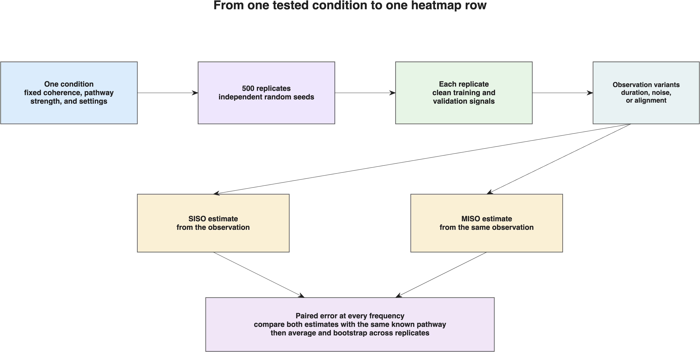
Figure 3. Simulation hierarchy. Each tested condition was repeated with 500 random signal realizations. SISO and MISO were evaluated on the same observations before errors were averaged across replicates.

The paired replicate errors were resampled together 2,000 times. The standard deviation of the resampled advantages estimates the Monte Carlo uncertainty caused by using a finite number of replicates. The prespecified target was a maximum standard error of 0.05 advantage units in every finite primary heatmap cell.

Table 2. Numerical precision of the four primary heatmaps.
Map | Maximum MC SE | Finite cells | Passing cells | Paired N
Input coherence | 0.0310 | 136 | 136 | 500–500
CO₂ pathway ratio | 0.0276 | 102 | 102 | 500–500
Recording duration | 0.0276 | 68 | 68 | 500–500
Output SNR | 0.0276 | 102 | 102 | 500–500

As an implementation check, the expected population SISO mixing error was also calculated directly from the known input spectra and pathways. This verification quantity was not treated as an additional study endpoint.

Held-out NC validation
Each NC recording was divided into three non-overlapping 90-second blocks. Transfer functions were estimated from two blocks and used to predict CBFV in the third. Each block served once as the held-out block. Errors were averaged within each subject, and subjects were resampled 2,000 times to obtain pointwise 95% bootstrap intervals. The NC SISO comparator used MAP alone; MISO used MAP and CO₂. This analysis measures prediction on unseen blocks and does not identify the true human pathways.

Reproducibility
The simulation saved its random seed, settings, exact factor selections, family seeds, source tables, and run manifest. The same settings and seeds regenerate the same input recordings, response kernels, observations, estimates, and figures. The manuscript assets can be rebuilt from the archived numerical outputs without rerunning the full production simulation.

Results
The results use the same layout throughout. Frequency is on the horizontal axis, the tested level of one quantity is on the vertical axis, and color shows the MISO advantage. Positive values indicate lower recovery error with MISO; negative values indicate lower recovery error with SISO. Each primary panel varies only its named quantity; the other settings remain at the declared reference values.

Production completion and precision
The final production archive contained 52,000 paired analyses across the primary and sensitivity experiments. All finite cells in the four primary heatmaps met the prespecified Monte Carlo standard-error target of 0.05 advantage units. The largest observed standard error was 0.0310, with 500 paired replicates in each finite cell.

Primary MAP-pathway recovery
The MAP-pathway maps show that the MISO advantage depends on both the second pathway and the information available to distinguish the inputs. Input coherence of 0, 0.15, and 0.50 generally favored MISO. At 0.95, the advantage approached zero and included both positive and negative frequencies because MAP and CO₂ carried little independent information.
When the CO₂ pathway was absent, MAP-only SISO had lower MAP-pathway recovery error because there was no second pathway for it to omit, whereas MISO still estimated an additional coefficient. When the CO₂ pathway was as strong as the MAP pathway, MISO had lower error through much of the reporting band. Longer recordings increased the MISO advantage, while severe CBFV output noise reduced it.

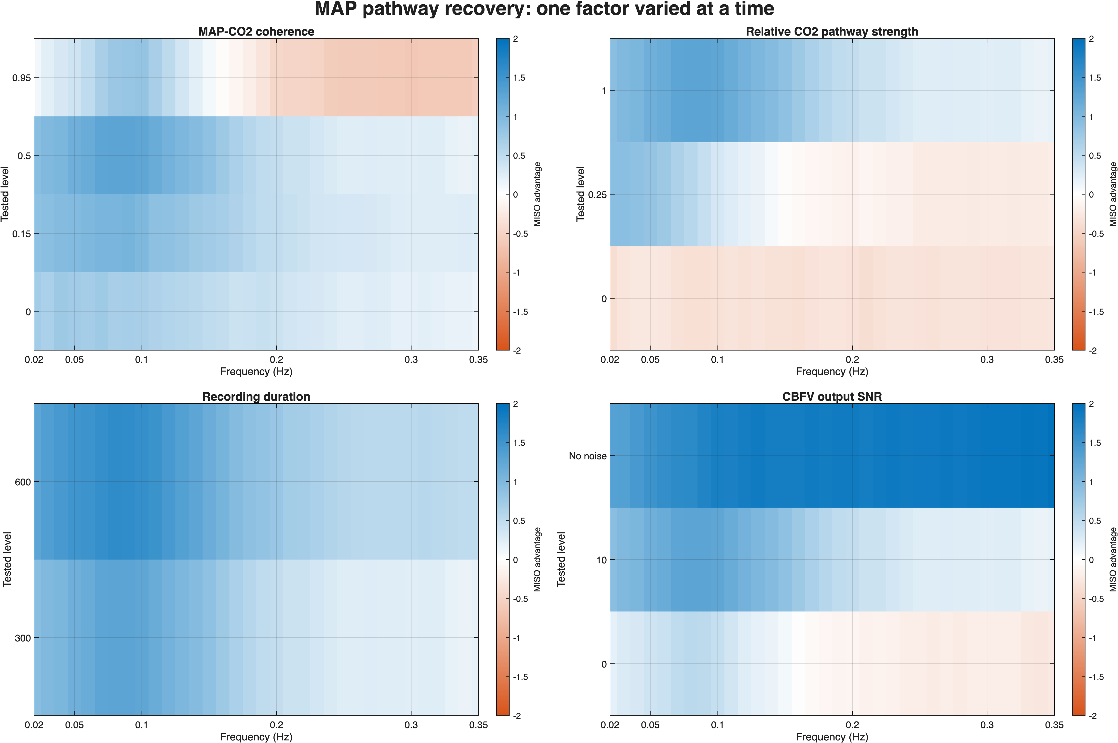
Figure 4. MAP-pathway recovery when one quantity was varied at a time. Positive values favor MISO; negative values favor MAP-only SISO. Each panel holds the remaining reference settings fixed.

Primary CO₂-pathway recovery
The CO₂-pathway maps compare MISO with CO₂-only SISO. They ask whether the CO₂ response is recovered more accurately when MAP is included in the joint model. MISO benefited from a meaningful second pathway and longer recordings, whereas very high input coherence and severe output noise reduced its advantage. MAP and CO₂ results are shown separately because recovery of one pathway does not imply recovery of the other.

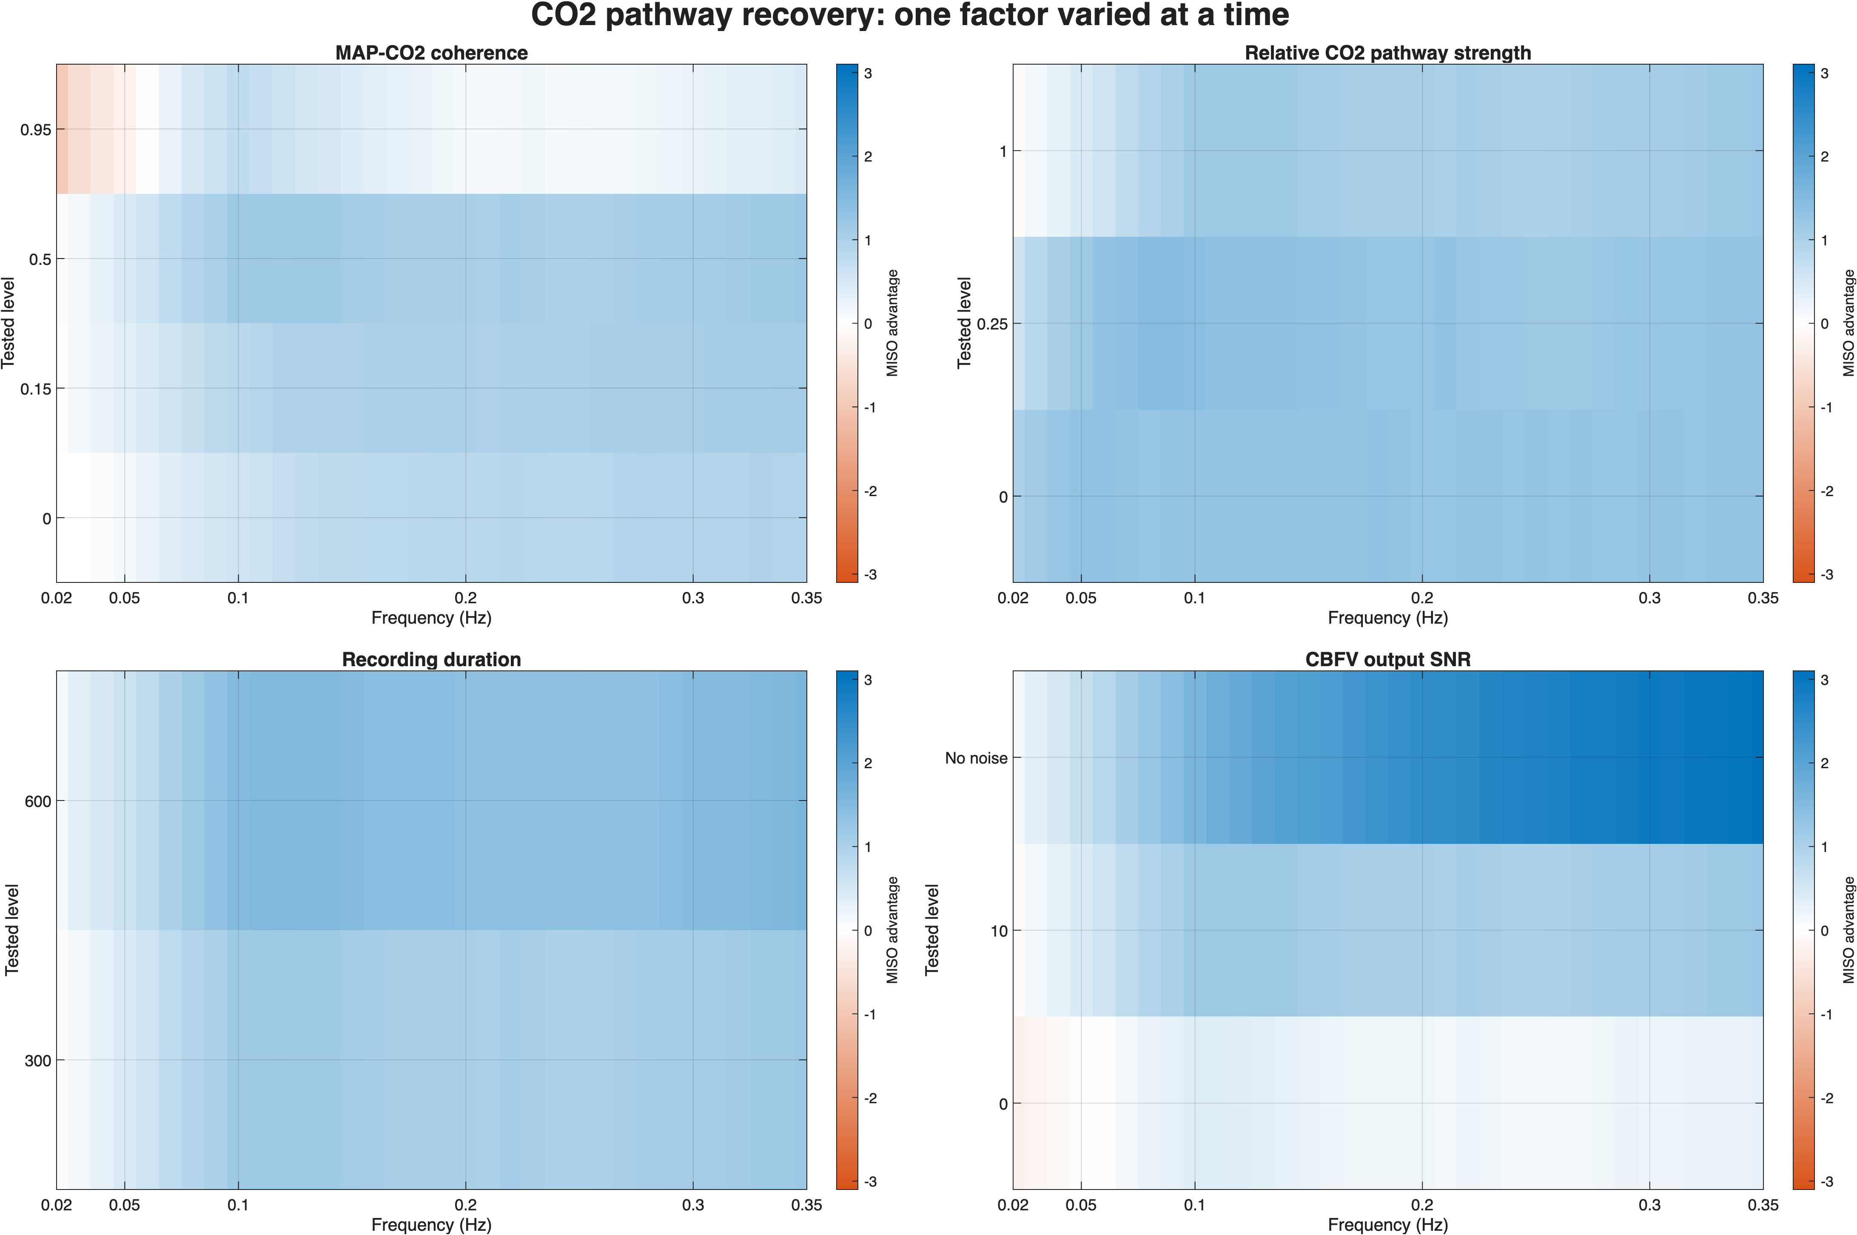
Figure 5. CO₂-pathway recovery when one quantity was varied at a time. Positive values favor MISO; negative values favor CO₂-only SISO.

Recording sensitivity
Increasing measurement noise in either input reduced the information available to estimate its associated response. Shifting the recorded CO₂ channel away from the timing used to generate CBFV also weakened the comparison. These experiments describe recording and processing sensitivity; they do not change the underlying generating pathways.

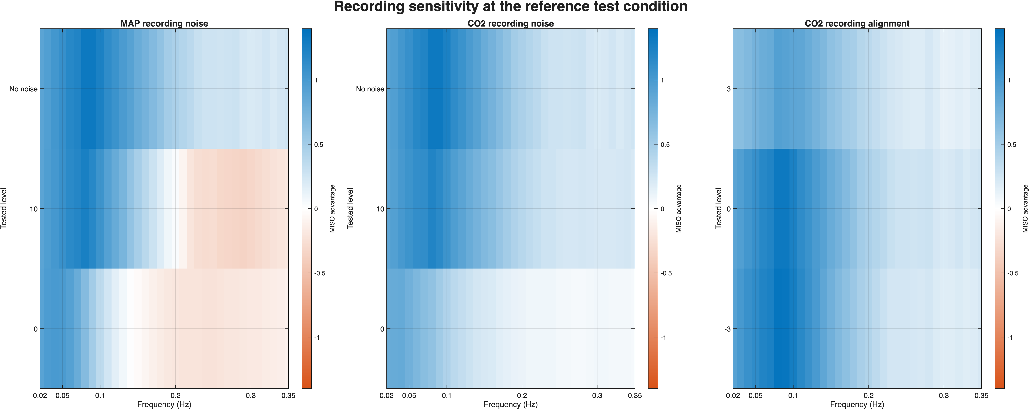
Figure 6. MAP-pathway sensitivity to input recording quality and CO₂ alignment. Each panel varies only its named quantity. Positive values favor MISO; negative values favor MAP-only SISO.

Timing sensitivity
The MAP–CO₂ input-lag experiment showed a positive MISO advantage at coherence 0.15 and 0.50 across the tested timing levels. At coherence 0.95, the maps contained both positive and negative regions. Timing therefore interacted with input separability: a timing difference does not compensate for inputs that are otherwise too redundant.

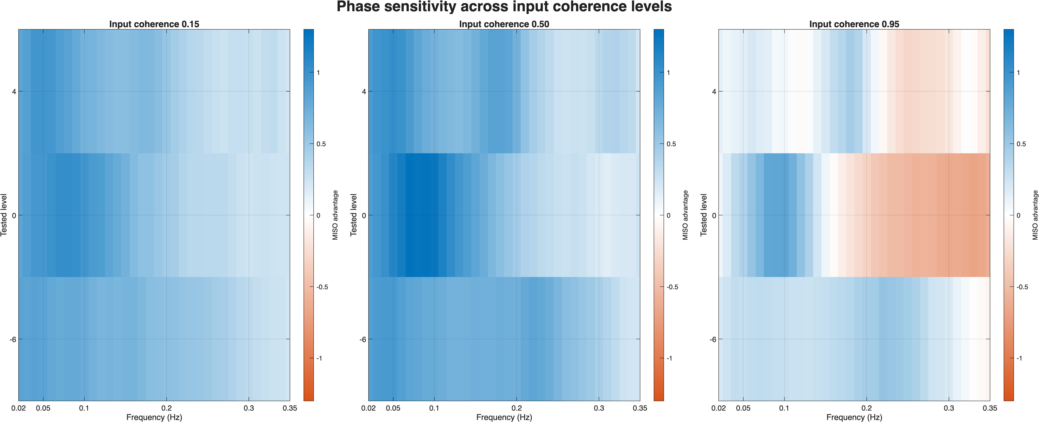
Figure 7. MAP-pathway sensitivity to MAP–CO₂ input timing at input coherence 0.15, 0.50, and 0.95. Positive values favor MISO; negative values favor MAP-only SISO.

Held-out NC validation
The NC analysis used held-out CBFV prediction because true human transfer functions were unknown. Across 30 retained frequencies, all point estimates of the MISO advantage were negative, ranging from −0.440 to −0.077. The pointwise bootstrap interval was entirely below zero at 26 frequencies and included zero at four frequencies. Under this protocol and dataset, MAP-only SISO predicted held-out NC blocks more accurately than MISO over the analyzed band.
This result does not contradict a positive MISO truth-recovery advantage in some simulation conditions. The endpoints differ. The simulation measures recovery of known generating pathways, whereas the NC analysis measures prediction of CBFV without access to human pathway truth. The NC result therefore supports MAP-only SISO for this held-out prediction task and dataset; it does not establish which estimator recovered the unknown physiological pathways more accurately.

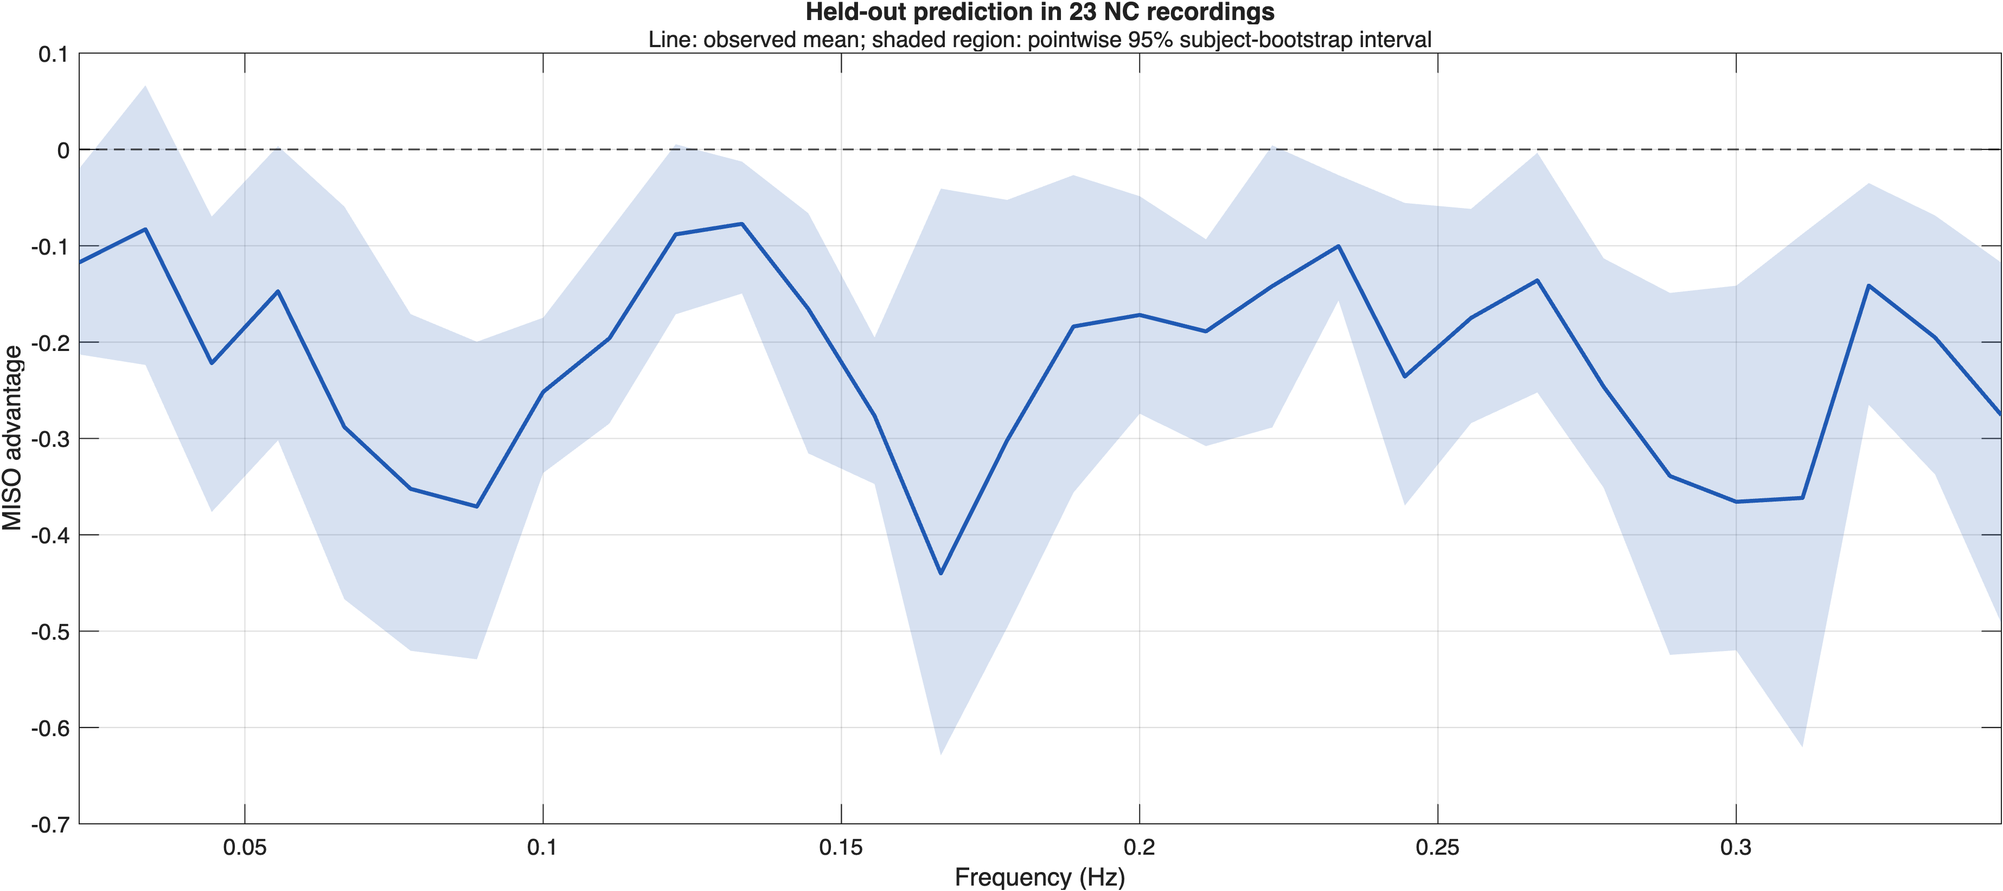
Figure 8. Held-out CBFV prediction in 23 NC recordings. Negative values indicate lower prediction error with MAP-only SISO; positive values indicate lower prediction error with MISO. The shaded region is the pointwise 95% subject-bootstrap interval.

References
Panerai RB, Brassard P, Burma JS, et al. Transfer function analysis of dynamic cerebral autoregulation: a CARNet white paper 2022 update. J Cereb Blood Flow Metab. 2023;43:3–25. doi:10.1177/0271678X221119760. PMID: 35962478.
Hoiland RL, Fisher JA, Ainslie PN. Regulation of the cerebral circulation by arterial carbon dioxide. Compr Physiol. 2019;9:1101–1154. doi:10.1002/cphy.c180021. PMID: 31187899.
Panerai RB, Simpson DM, Deverson ST, Mahony P, Hayes P, Evans DH. Multivariate dynamic analysis of cerebral blood flow regulation in humans. IEEE Trans Biomed Eng. 2000;47:419–423. doi:10.1109/10.827312. PMID: 10743786.
Peng T, Rowley AB, Ainslie PN, Poulin MJ, Payne SJ. Multivariate system identification for cerebral autoregulation. Ann Biomed Eng. 2008;36:308–320. doi:10.1007/s10439-007-9412-9. PMID: 18066666.
Chertoff ME, Billinger SA, Perdomo SJ, et al. A novel nonlinear system identification for cerebral autoregulation in human: computer simulation and validation. Ann Biomed Eng. 2020;48:1207–1217. doi:10.1007/s10439-019-02442-7. PMID: 31873829.
Westwick DT, Pohlmeyer EA, Solla SA, et al. Identification of multiple-input systems with highly coupled inputs. Neural Comput. 2006;18:329–355. doi:10.1162/089976606775093855.
Welch PD. The use of fast Fourier transform for the estimation of power spectra. IEEE Trans Audio Electroacoust. 1967;15:70–73. doi:10.1109/TAU.1967.1161901.

